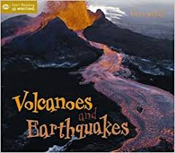

**Smart Zone Autumn 2023 Topic Web**

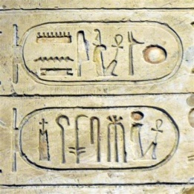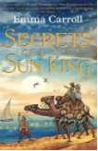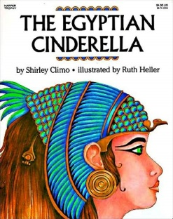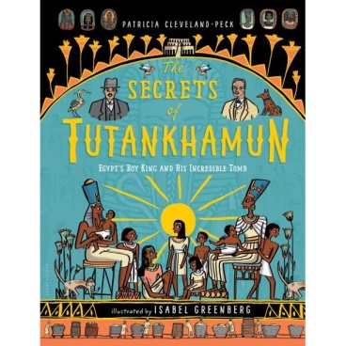[](https://www.bing.com/images/search?view=detailV2&ccid=w5jy7WLA&id=C07956BB298E450705E72D0A40BA575AD76B5C29&thid=OIP.w5jy7WLA0KE7QCKeBpFgogHaF7&mediaurl=http://images.rarenewspapers.com/ebayimgs/1.62.2014/image041.jpg&exph=512&expw=640&q=britain+declares+war+1939&simid=608052872598522884&selectedIndex=2)

**English**

**Whole Class Guided Reading Text – Secrets of a Sun King – Emma Carroll**

**The Egyptian Cinderella –** Traditional Stories

**Dream Giver –** Stories from imaginary worlds

**Maths**

1. **Investigating Number Systems**
2. **Pattern Sniffing**
3. **Solving Calculation Problems**
4. **Generalising Arithmetic**
5. **Exploring Shape**
6. **Reasoning with Measures**