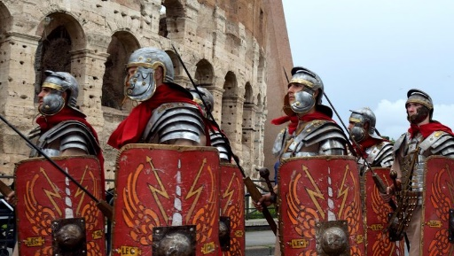

**Smart Zone Spring 2024 Topic Web**

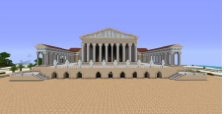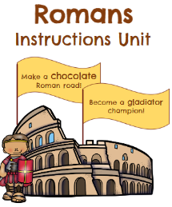[](https://www.bing.com/images/search?view=detailV2&ccid=w5jy7WLA&id=C07956BB298E450705E72D0A40BA575AD76B5C29&thid=OIP.w5jy7WLA0KE7QCKeBpFgogHaF7&mediaurl=http://images.rarenewspapers.com/ebayimgs/1.62.2014/image041.jpg&exph=512&expw=640&q=britain+declares+war+1939&simid=608052872598522884&selectedIndex=2)

**English**

**Escape from Pompeii -**

**Roman Instructions –** How to make a Roman Road / How to become a Gladiator

**Weslandia** – Paul Freischman

**Romans on the Rampage** – Jeremy Strong

**Maths**

1. **Generalising Arithmetic**
2. **Exploring Shape**
3. **Reasoning with Measures**
4. **Discovering equivalence / fractions**
5. **Solving Number problems**