Sithney School Curriculum Overview
Our thinking threads: ‘there, here, then, now, next’
Cycle A Year 24/25
Autumn Term |  | Spring Term |  | Summer Term
Writing focus
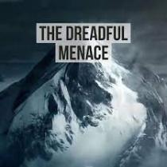  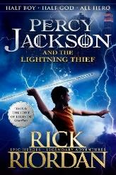 | 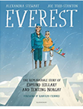  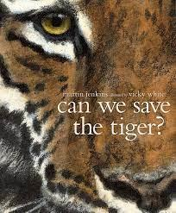 |  | 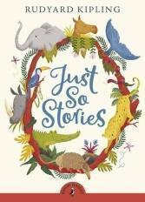  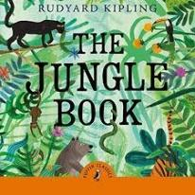 | No text stimulus, but Year 5’s to work on creating setting, developing character emotions and dialogue - PPP to help enhance and support writing during Year 6 SATS work. | 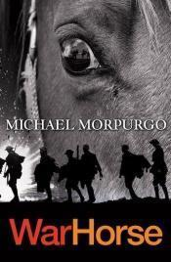  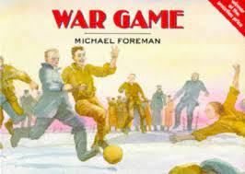
Rationale for choice….  Grammar and English unit of work that supports the teaching of the Ancient Greeks. Lots of opportunity to create own writing and develop grammar skills. Science fiction/ mythical novel.  Poetry Unit based on Mountains. Good stimulus for figurative language. | Text linking to evolution and inheritance in Science. Enables children to learn about a range of creatures that have become extremely endangered.  Writing Unit focussing on climbing Everest. Based on the story of Edmund Hilary and Tenzing Norgay standing on the summit of Everest. |   The lonely planet guide layout to persuade children to visit real places. Pupils copy format to entice people to places in books. Children to write their own class travel book of fantasy places. | Children to look at how the author separates narrative from dialogue through the language used in the texts. Links with Science where children are learning about living things and their habitats.  Tyger Tyger Poetry unit (William Blake) - explore classical poetry linked to the theme of science and other texts this term. Links with the jungle book. | Supports creative writing and helping children to enhance character emotions, actions/movement, dialgue and settings. | Historical fiction. Relates to work on WWI- Good quality text with adventurous vocabulary.  War Game is another link with WW1 using historical fiction and supports the teaching of War Horse.
Additional reading
Percy Jackson and the Lightning Thief (Rick Riordan) | 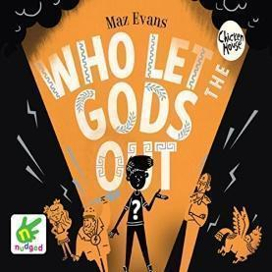  Who Let the Gods out  (Maz Evans) | 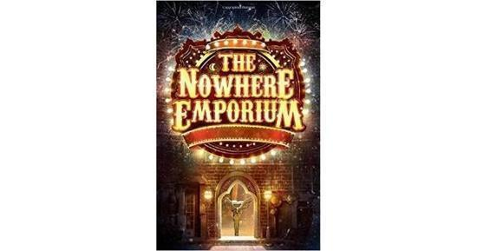  The Nowhere Emporium  (Ross Mackenzie) |  | War Horse  (Michael Morpurgo)
Rationale for choice….  Guided reading as well as focus, due to the reading chapters for us to base our work on | Linking to the Ancient Greeks as a history focus. Exposure to a humorous text. | A text focussing on magic and fantasy. Fantastic examples of adventurous language to create amazing expanded noun phrases. Specific detailed descriptions creating good imagery. Engaging for all readers – gender neutral. Suspense and tension; character descriptions. |  |  | Historical fiction. Relates to work on WWI- Good quality text with adventurous vocabulary
Additional reading- non fiction
Myths  Non-fiction texts linked to topic work | Poetry  Non-fiction texts linked to topic work | Novel extracts  Non-fiction texts linked to topic work | Poetry and Songs | War Poetry  Non-fiction texts linked to topic work | Non-fiction texts linked to topic work
Science
Evolution and classification |  | Living things and their habitats | (Plant and Animal Life cycles) | Forces | Electricity
Geography
 | Mountains |  | Who are National Parks for? |  | Comparing People and Places
History
Ancient Greece (and influence on the western world) |  | British Empire (CH) |  | World War 1  1914- 1918
Art
 | Drawing: I need space | Painting and mixed media: Portraits |  | Drawing: Make my voice heard
Design Technology
Cooking and Nutrition |  |  | Mechanical Systems |  | Electrical Systems
Computing
Year 5: Programming A: First use Microbits  Year 6: Programming A: Variables in games  E-safety:  Self-Image & Identify Privacy & Security | Year 5: Programming B: Selection in Quizzes  Year 6: Programming B: Sensing with Microbits  E-safety:  Self-Image & Identify Privacy & Security | IT Around Us: Systems & Searching  E-Safety:  Online Bullying  Online Reputation | Digital Design: Vector Graphics  E-Safety: Managing Information Online | Data & Information: Spreadsheets  E-Safety:  Health, Well-being & Lifestyles Online Relationships | Digital Design: Web Page Creation  E-Safety:  Copyright & Ownership Online Relationships
Music
First Access – Music Technology  Or Looping and Mixing |  | Dynamics, pitch and texture (Theme: Coast – Fingal's Cave by Mendelssohn) |  | Songs of World War 2 | Composing and performing a leavers’ Song
MFL
Unit 1  Salut Gustave!  Greet people and give personal information Ask and talk about sisters and brothers  Say what people have and have not using 3rd person avoir  Say what people are like using 3rd person être including negatives | Unit 2  A l’ecole  Name school subjects Talk about likes and dislikes at school  Ask and say the time  Talk about timings of the school day | Unit 3  La nourriture  Ask politely for food items  Describe how to make a sandwich  Express opinions about food  Talk about healthy and unhealthy food | Unit 4  En ville  Name places in the town  Ask the way and give directions  Say where you are going  Give the time and say where you are going | Unit 5  En vacances  Ask and say where you’re going on holiday  Express opinions about holidays  Talk about what you’re going to do on holiday  Talk about holiday plans | Unit 6  Chez moi  Name rooms in the house  Describe rooms in the house  Say what people do at home  Say what people do and where
Physical Education & Sport
Handball  Gymnastics  Counter balance and counter tension | Handball  Swimming | Basketball  Gymnastics – matching and mirroring | Basketball  Dance – The circus | Badminton  Rounders | Badminton  Rounders
Religious Education
What does it mean if Christians are holy and loving?  (God) | What does it mean to be a Muslim in Britain today?  (faith/worship) | Why do Christians believe Jesus was the Messiah?  (Incarnation) | Why is the Torah so important to Jewish people?  (God/Torah) | How do Christians decide how to live- what would Jesus do?  (Gospel) | What matters most to Humanists and Christians?
PSHE & RSE
Introduction: setting ground rules for RSE & PSHE lessons (1 lesson  Families and Relationships (8 lessons)  Health and well-being (5 lessons) |  | Health and well-being (2 lessons)  Safety and the Changing body (8 lessons)  Final 3 lessons to be taught separately – RSE/Puberty  Citizenship (2 lessons) |  | Citizenship (4 lessons)  Economic Wellbeing (5 lessons)  Identity (2 lessons)  Transition (1 lesson)
Mathematics
Y5 Place Value  Addition and Subtraction  Y6 Place Value  Addition, Subtraction, Multiplication and Division | Multiplication and Division A  Fractions A  Fractions A  Fractions B  Converting Units | Multiplication and Division B  Fractions B  Ratio  Algebra  Decimals | Decimals and Percentages  Perimeter and Area  Statistics  Fractions, Decimals and Percentages  Area, Perimeter and Volume  Statistics | Shape  Position and Direction  Decimals  Shape  Position and Direction | Negative Numbers  Converting Units  Volume  Themed Projects, Consolidation and Problem Solving

