Pupil premium strategy statement – Sithney Primary School
This statement details our school’s use of pupil premium (and recovery premium) funding to help improve the attainment of our disadvantaged pupils.
It outlines our pupil premium strategy, how we intend to spend the funding in this academic year and the outcomes for disadvantaged pupils last academic year.

School overview
Detail | Data
Number of pupils in school | 82
Proportion (%) of pupil premium eligible pupils | 12% (10/82)
Academic year/years that our current pupil premium strategy plan covers (3 year plans are recommended – you must still publish an updated statement each academic year) | 2025/2026
Date this statement was published | 12.12.25
Date on which it will be reviewed | October 2026
Statement authorised by | Vicky Sanderson
Pupil premium lead | Vicky Sanderson (EHT)  Helen Neil (HoS)
Governor / Trustee lead | William Coleman

Funding overview
Detail | Amount
Pupil premium funding allocation this academic year | £14,800
Recovery premium funding allocation this academic year  Recovery premium received in academic year 2023/24 cannot be carried forward beyond August 31, 2024. | £0
Pupil premium funding carried forward from previous years (enter £0 if not applicable) | £0
Total budget for this academic year  If your school is an academy in a trust that pools this funding, state the amount available to your school this academic year | £14,800

Part A: Pupil premium strategy plan

Statement of intent
At Sithney Community Primary School, we have the highest expectations for all of our children, including our vulnerable pupils. Our focus on the whole child ensures that we promote and develop self-esteem and self-worth as priorities, knowing that these are the building-blocks to positive relationships in school, and with education. The school promotes the importance of good attendance, targeting poor attendance and persistent lateness, and focuses on early Numeracy and Literacy skills to support children with a secure and stable start to school life. We promote the Virtues Project and focus on developing oracy skills, to enable pupils to advocate themselves clearly and be exposed to an enriched language – which promotes self-efficacy and develops personal growth.
We recognise the power of reading to unlock learning and opportunities for pupils. This is particularly important for disadvantaged pupils, opening the door to new worlds, ideas and people. The teaching of reading and application of these skills are core to our curriculum.
We are committed to developing and maintaining high quality teaching at the heart of our approach, with a focus on the areas which our disadvantaged children require the most support.
If everyone in the places we serve are to thrive, we need to effectively work with, and for, our communities building strong local relationships. Our hope is that through our work, we can develop meaningful connections with the families and community organisations within our localities.
We, as teachers, hold ourselves accountable for the progress and outcomes of our pupils, understanding that when our expectations are high, children will rise to them in a self-fulling cycle of high expectations leading to high levels of self-efficacy and sense of agency, and therefore high achievement. We fully believe that when we unlock learning, we enable life-long life choices.

Challenges
This details the key challenges to achievement that we have identified among our disadvantaged pupils.
Challenge number | Detail of challenge
1 | Pupils live in a predominantly monocultural and geographically isolated part of Britain which limits their exposure to, and knowledge of, the diverse range of cultural backgrounds beyond their own community
2 | The word-gap between children living in disadvantage and their peers is large.
3 | Our attendance data indicates that disadvantage children’s’ attendance is lower than that of non-disadvantaged.  Our assessments and observations confirm that this negatively impacts on progress.
4 | Many of our pupils in receipt of FSM, lack appropriate access to the internet or devices at home, this can lead to a lack of understanding of purposeful technology use, low confidence in school with use of technology or risky behaviours online.
5 | Increasing numbers of children show the signs and symptoms of low self-efficacy: avoidance of challenge, low motivation, self-doubt, anxiety and stress.
6 | Many of our children and families face multiple impacts of disadvantage. In order to narrow or eliminate the disadvantage gap, the work required is greater than that within the scope of the school working alone.
7 | Disadvantaged pupils typically take longer to progress through the phonics programme. This negatively impacts their development as readers.

Intended outcomes
This explains the outcomes we are aiming for by the end of our current strategy plan, and how we will measure whether they have been achieved.
Intended outcome | Success criteria
To enrich and broaden our children’s understanding of cultural diversity within Britain and around the world | Children have a knowledge of the cultural diversity within their own community, the UK and beyond. They are inquisitive and talk positively about a range of cultures different to their own.
To decrease the word-gap between children living with disadvantage and their peers. | Teachers deliver quality first teaching for oracy including a daily reading for pleasure session – to inspire and develop an enjoyment of stories.
To improve attendance of disadvantaged pupils and reduce the percentage of lateness. | Children will be in school and this will positively impact their academic, social and emotional progress.
To develop a digital strategy which builds on skills developed within computing across the curriculum to enable pupils to learn and stay safe online. | Children are able to think critically, understanding when and how to use technology appropriately, understanding risks and advantages.
To raise children’s self-efficacy: their belief in their actions make a difference and therefore able to succeed. | Children have increased confidence in their ability to learn and succeed. Staff have the skills to promote self-efficacy through quality first teaching. School Culture promotes self-efficacy for all stakeholders.
To improve links between school and support networks within the community. | Improved links and shared working between the school and wider community organisations and parents will support families in a wider capacity than can be achieved within the school individually which in turn will impact positively on outcomes.
To improve phonics and reading attainment for disadvantaged children | Outcomes inline with or above national average.

Activity in this academic year
This details how we intend to spend our pupil premium (and recovery premium) funding this academic year to address the challenges listed above.

Teaching (for example, CPD, recruitment and retention)
Budgeted cost: £ [14,450]
Activity | Evidence that supports this approach | Challenge number(s) addressed
Regular use of the ‘Lyfta’ resource is achieved within school through:  -planning Lyfta into school assembly plans  -introducing ‘Lyfta time’ to enable classes to ‘explore’ on a regular basis  -articles being utilised to support non-fiction reading lessons (as appropriate) | hundrED recommended resource “helps teachers to nurture empathy, active citizenship and 21st Century skills.” | 1
Through the Trust RE network group, Lyfta resources will be mapped against the curriculum | Teacher Toolkit recommended resource to develop cultural capital and enrichment, providing valuable and cost-effective experiences. | 1
CPD for teachers and TAs to support quality first teaching in relation to oracy.  Development of English and Maths vocabulary displayed and referred to in lessons. | “Professional development can support whole school approaches to close the word gap for disadvantaged pupils.”  ROYAL COLLEGE OF SPEECH & LANGUAGE THERAPISTS | 2
CPD for teachers and TAs to support quality first teaching in relation to developing and promoting self-efficacy: praising for effort and use of strategies; positive noticing; finding pivotal moments; recognising the importance of challenge; creating opportunities for roles of responsibility. | Gutman and Schoon (2013) “Non-cognitive skills are vital for educational success.  Schunk (1981): Self-efficacy as a predicator of academic performance  Betthaeuser et al. (2020): Impact on academic outcomes, mental health and social factors. | 5
Additional set of RWI phonics programme ditty books and Book Bag Books purchased. RMT Portal and Leadership Development | Phonics approaches have a strong evidence base that indicates a positive impact on the accuracy of word reading (though not necessarily comprehension), particularly for disadvantaged pupils: Phonics | Toolkit Strand | Education Endowment Foundation | EEF | 7
Teacher CPD in teaching of reading (post phonics) | - EEF research found that using the Pupil Premium to improve teaching quality benefits all students and has a particularly positive effect on children eligible for the Pupil Premium Clear programme of support and development to ensure all staff deliver quality first teaching in every lesson. | 7

Targeted academic support (for example, tutoring, one-to-one support, structured interventions)
Budgeted cost: £ [5,000]
Activity | Evidence that supports this approach | Challenge number(s) addressed
Phonics tutoring in place for children with gaps in early reading.  Fluency for reading post phonics utilising the HFL strategy I develops confidence and supports comprehension | EEF evaluation Autumn term 2024/Spring 2025.  Strong foundations in the first years of school. October 2024 | 2  2

Wider strategies (for example, related to attendance, behaviour, wellbeing)
Budgeted cost: £ [£1024]
Activity | Evidence that supports this approach | Challenge number(s) addressed
Parent workshops for children in EYFS, to raise the importance of reading with young children. | Reference list from the Book Trust’s “Getting Children Reading” strategy.  John Hattie (2008) estimates that the effect of parental engagement is equivalent to two to three additional  years learning over a pupil’s school career. | 2
Parent workshops supporting online safety. (HCC) | South West Grid for Learning | 4
School to work with families to improve attendance.  Work with the County Attendance Officer.  School to commit to the Crofty procedure for raising attendance. | Working Together to Improve School Attendance August 2024 | 3
Working within the Trust’s Community Strategy, the school will identify a current link held with a local organisation that can be further developed. Through active listening to the organisation, the school will identify an objective that can be worked on together to strengthen the community offer. | Reach Foundation Insights; CST work on School Trusts as New Civic Structures; Truly Civic: Strengthening the connection between universities and their places. | 6

Total budgeted cost: £ 14,800

Part B: Review of the previous academic year

Outcomes for disadvantaged pupils
Due to small cohorts with small numbers of PP, whole school data has been provided so as not to identify individuals.
2024-2025 results 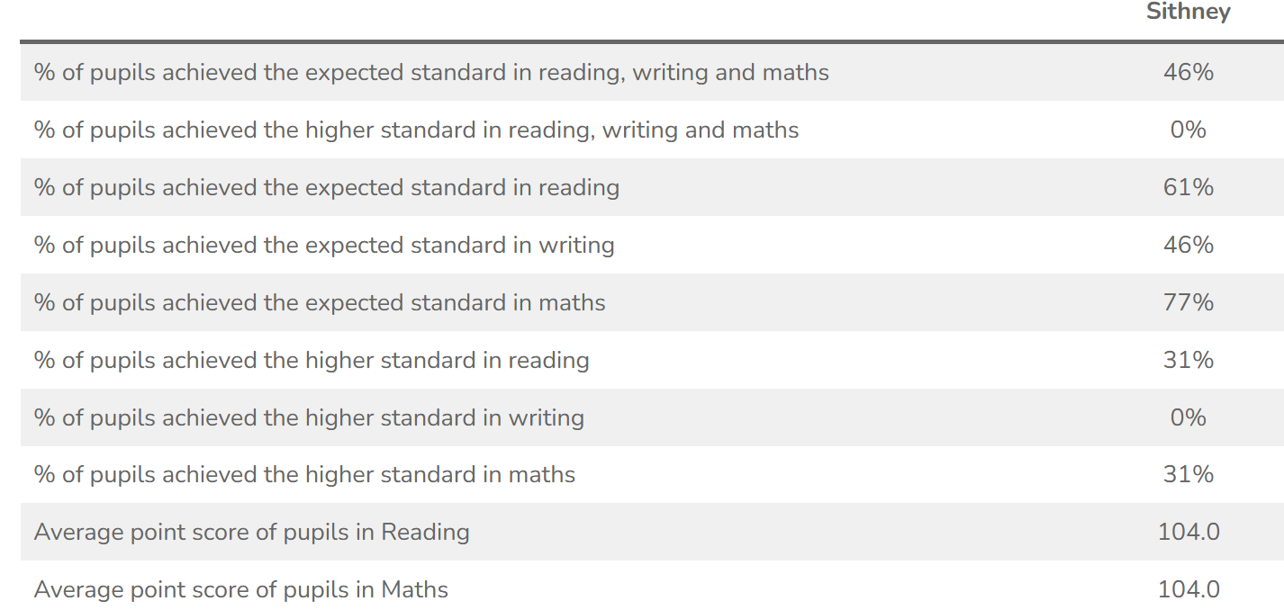

2024-25 |  | %
EYFS | YR children at expected | 77%
Phonics | Yr1 pupils at expected | 75%
Phonics | Yr2 children who passed retake | 100%
MTC – Y4 | Average score | 22.25
MTC – Y4 | children achieving full marks | 3 (25%)

In the 2024-25 data at all statutory year 6 SATs a decline for pupils in recipient of PPG was seen, compared to those not in receipt of PPG. (Small cohort)

In 2024-25 PSC a decline for pupils in recipient of PPG was seen, compared to those not in receipt of PPG. (VERY small cohort)

In EYFS ELG a decline for pupils in recipient of PPG was seen, compared to those not in receipt of PPG. (VERY small cohort)

Feedback from parents’ survey 2024-25
100% of parents feel that:
- My child is happy at this school.
- My child feels safe at this school.
- If my child was being bullied, I could talk to the school about it and they would help.
- My child makes good progress at this school.
- The school lets me know how my child is doing.
- My child is well looked after at this school.
- The school provides a wide range of activities to enhance their learning (trips, visitors, performances, clubs).
- My child has SEND and the school gives my child the support they need to succeed.

Attendance: Where attendance was below the school expectation, further support and provision was put in place, including meeting with families and sending letters to inform them of their child’s overall attendance. Letters are sent to all parents to explain the impact absences from school have their academic progress (at the beginning of the school year). There was an improvement in PP attendance in 2024-25 = 93.1% PP compared to 91.6% PP in 2023-24.
Moderation of writing with other schools has highlighted use of adventurous language within pupils writing as a positive, however presentation, handwriting, spelling and grammar area areas for continued development. Pupil conferencing has shown that pupils enjoy writing.
Tier 2 and tier 3 words are a focus in lessons, being displayed in classrooms and discussed within lessons. Adventurous words are celebrated in a weekly assembly and these words are evident in the pupils writing.
Book looks and pupil conferencing identify pupil progress.
School has purchased reading session books so every child has their own book in lessons. Recommended reads for each year group were purchased to replenish our library.

All PP pupils had first access and equal opportunity to attend clubs, trips, residentials and Outdoor Learning activities (Newquay residential –surfing, coasteering…) This has added to their sense of place and sense of belonging.

Externally provided programmes
Please include the names of any non-DfE programmes that you used your pupil premium (or recovery premium) to fund in the previous academic year.
Programme | Provider
Accelerated read | REN Learn
Maths Whizz | Our People
Read Write Inc | Ruth Miskin
Kapow | Kapow Primary Company
Mastering Number | NCTEM
ParentPay | ParentPay
White Rose Maths | White Rose Maths

