Sithney School Curriculum Overview
Our thinking threads: ‘
Cycle A Year 4/5/6
Autumn Term |  | Spring Term |  | Summer Term
Writing focus
Hermelin (Whole School Unit)  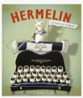  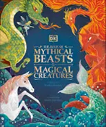  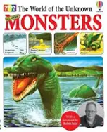  Non-chronological report | Description  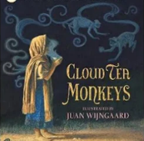  Poetry: Cinquains  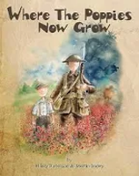  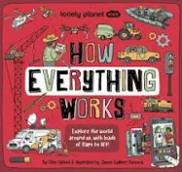  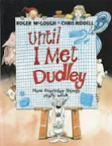  Explanation | Narrative  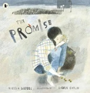  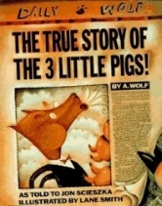  Persuasive Speech  Balanced Argument  (no book) | Newspaper Reports/Recounts  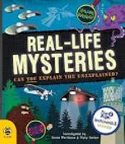  Poetry: Haiku  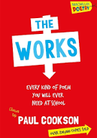 | Narrative  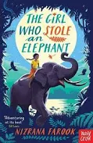  Persuasive Letters  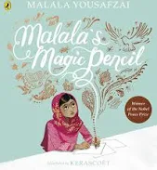 | Biography  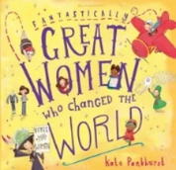  Poetry  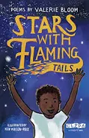
Hermelin  To provide some ‘benchmark’ writing outcomes for the start of the school year. The writing opportunities should also promote in the children a love for, and pleasure in, writing for themselves and for an audience.  The World of Unknown Monsters  acts as a high-engagement hook. It bridges creative fiction with non-fiction structures, allowing pupils to master formal language, paragraphing, and technical vocabulary by investigating and detailing legendary beasts. | Cloud Tea Monkeys:  The book's vibrant Himalayan setting and magical elements provide excellent opportunities for children to use powerful adjectives, expanded noun phrases, fronted adverbials, and rich sensory language  Where the Poppies Grow:  Its unique structural formatting and poignant historical themes directly mirror the requirements of the five-line poetic form.  Until I met Dudley:  it models both imaginative and factual explanation, engaging children and showing them how to break down complex processes into clear, logical, step-by-step texts. | The Promise  It provides a powerful, multi-sensory foundation for teaching descriptive language, emotional narrative writing, and persuasive letters.  The True Story of the Three Little Pigs.  It teaches children how to manipulate point of view, handle bias, and structure persuasive arguments. | Real Life Mysteries It bridges the gap between engaging storytelling and the strict structural constraints of non-fiction journalistic writing. The interesting mysteries naturally hook reluctant readers and writers. | The Girl Who Stole an Elephant  Its exciting storyline and realistic main character help keep children interested. The story also provides lots of opportunities to explore descriptive language, understand characters’ feelings and actions, and build suspense.  Malala’s Magic Pencil  It gives children a real-life reason to use their grammar skills, helping them see how writing can be used to share ideas, support others, and make a difference. | Great Women of the World  It helps children develop important research and writing skills, such as finding information, organising events in order, and writing about someone else. It also introduces inspiring role models from different backgrounds, helping children stay engaged and challenge ideas about who can make history.  Stars with Flaming Tails  A poetry collection that broadens children’s imaginations and inspires their own creative writing. It details poetic forms (like riddles and limericks) and explores figurative language (personification and metaphor).
Additional reading – Reading Sessions Fiction
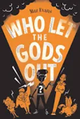 | 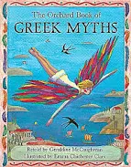 | 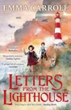 | 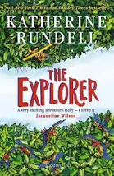 | 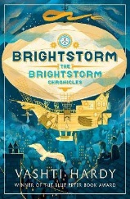 | 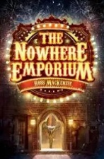
It seamlessly links to our Ancient Greece top while tackling sensitive real-world themes. It hooks reluctant readers through accessible, fast-paced humor and rich characterisation, where children can explore deep emotional topics—such as mental health and young carers—in a relatable, safe way. | It features 16 accessible retellings of classic Greek myths and strikes an excellent balance between rich, sophisticated vocabulary and engaging, easy-to-follow storytelling. The tales are presented in a child-friendly way, making complex myths enjoyable and accessible while still providing opportunities to extend vocabulary and deepen understanding. | A brilliant text that brings the WW2 history curriculum to life (links to hour history topic). It covers major wartime themes, including the London Blitz, evacuee experiences, codebreaking, and the Home Front, all wrapped in a gripping mystery | The journey through the Amazon rainforest is full of danger, mystery, and suspense, making it especially appealing to reluctant readers. At the same time, the book introduces rich vocabulary and provides plenty of opportunities to develop skills such as comprehension, inference, understanding characters’ feelings and actions, and exploring how authors use language to engage readers. | It provides an action-packed, brilliantly inclusive narrative that boosts literacy skills through exceptional world-building, suspenseful pacing and cross-curricular links. | It’s highly imaginative fantasy setting and rich, descriptive language serve as an ideal vehicle for teaching upper primary literacy objectives.
Additional reading- Reading Sessions - Non Fiction
Greek Myths  Non-fiction texts linked to topic work | War Poetry  Non-fiction texts linked to topic work | Novel extracts  Non-fiction texts linked to topic work | Novel extracts  Non-fiction texts linked to topic work | Poetry  Non-fiction texts linked to topic work | Non-fiction texts linked to topic work
Science
Forces in Motion  How do forces and mechanisms affect the way things move? | Evolving Earth  How did living things become the way they are today? | Growing, Changing, Living  What do lifecycles reveal about how living things grow, change and age? | Circuits and Symbols  What affects the brightness, power or output of a circuit? | Ice, Life and Survival  How have plants and animals adapted to survive polar habitats? | Species Under Threat  How can we protect species that are under threat?
Geography
 | A Tale of Two Cities  What are settlements and how are they similar to and different from each other? |  | People and the Planet  What influences the way people live, trade and settle in a changing world? |  | Polar Planet  What makes the polar regions such unique and challenging places to live and experience?
History
The Greeks: A Lasting Legacy  How did Ancient Greece shape the world we know today? |  | Hope, Heroes and the Home Front  How did the Second world war transform people’s lives? |  | Tech Through Time: Inventions that…  How have key inventions changed the way people live, work and communicate?
Art
The Art of Light and Line  What do artists achieve by using, line, light and shadow in their work? |  | From Waste to Wonder  How can we create art to protect our environment? |  | Inuit Art  What can we learn from Inuit carving and printing techniques?
Design Technology
 | Building Through Time  What influences the way architects design structures over time? |  | Repair and Reuse  How can we repair and reuse textiles creatively? |  | Whole Foods, Healthy Choices  What makes a meal healthy?
Computing
Programming 2: BBC Micro:bit | Data Handling: Mars Rover 1 | Skills showcase: Mars Rover 2 | Computer Systems and Networks: Bletchley Park and the history of computers | Computer Systems and Networks:  Exploring AI | Skills Showcasing: designing a product
Music
Physical Education & Sport
Swimming  Dodgeball | Game Sense – Invasion  Dance - Greeks | Gymnastics – Counterbalance and Counter tension  Health Related Exercise | Dance – Street Art  Tag Rugby | Athletics – Running  Orienteering | Athletics – Throwing and jumping  Rounders
Religious Education
U2.1 What does it mean if Christians believe God is holy and loving?  God | U2.3 Why do Christians believe Jesus was the Messiah?  Incarnation | U2.9 Why is the Torah so important to Jewish people?  God/Torah | U2.4 Christians and how to live: ‘What would Jesus do?’  Gospel | U2.8 What does it mean to be a Muslim in Britain today?  Tawhid/iman/ibadah  (God,faith, worship) | U2.10 What matters most to Humanists and Christians?
PSHE & RSE
My healthy Self (Y6): How do my choices today shape my future health? | Connecting with others (Y5): Why are health relationships important? | The Online World (Y6): How do I feel about the things I see online? | Growing Up (Y5): How can I manage the changes to my body and emotions as I grow up?  * Growing Up (Y6): Sex Education: How do people become parents and carers?  * RSE taught separately | Citizenship (Y5): How can we be in control of our money? | Staying Safe (Y6): How can I stay safe as I grow up?
Mathematics
Y4 Place Value  Addition and Subtraction  Y5 Place Value  Addition and Subtraction  Y6 Place Value  Addition, Subtraction, Multiplication and Division | Y4 Measurement – Area  Multiplication and Division A  Y5 Multiplication and Division A  Fractions A  Y6 Fractions A  Fractions B  Measurement: Converting units | Y4 Multiplication and Division B  Length and Perimeter  Y5 Multiplication and Division B  Decimals and Percentages  Y6 Ratio  Algebra  Decimals | Y4 Fractions  Decimals A  Y5 Perimeter and Area  Statistics  Y6 Fractions, Decimals and Percentages  Area, Perimeter and Volume  Statistics | Y4 Decimals B  Money  Time  Y5 Shape  Position and Direction  Y6  Shape  Geometry: Position and direction | Y4 Shape  Statistics  Position and Direction  Y5 Negative Numbers  Measurement: Converting Units and  Volume  Y6 Themed projects and problem solving

